Booth Catering Order Form 2024

Our Catering Department is here to help make sure you have a very successful show. Our knowledgeable and helpful staff will assist you in planning all your food and beverage functions. From Show Management Offices, to Exhibit Booth deliveries, and cocktail receptions and special events, with your input we can develop custom menus to accommodate any specific theme.

Our Catering Department is the exclusive caterer for all patrons of the Sands Expo & Convention Center and we retain the exclusive rights for all food and beverage services therein.

It is not permissible to bring any food or beverage into the facility. This includes items for personal consumption. Any exception must be approved in writing. Failure to comply with this policy will result in a corkage fee in addition to any other damages to which the SECC may be entitled.

- F&B is permitted at MICE events, including self-service buffets.
- All participants consuming F&B at MICE events must be fully vaccinated.

GUARANTEES
The SECC Catering Department must be notified on the confirmed catering orders no later than 12 Noon two (2) business days (48 hours) prior to the first day of the scheduled function. Late orders will not be given a guaranteed delivery time.

PAYMENT / CANCELLATIONS
The SECC Catering Department requires full payment on all food and beverage orders by 5PM UTC 21 days prior to the date of the function. For all orders prepaid by wire transfer, client will pay for all transaction charges for remittances imposed by the agent bank and the receiving bank.

Cancellation policy is as follows:
- Less than 21 days but more than 10 days* - 50% of total order refunded
- 10 days but more than 3 days* - 25% of total refunded
- 3 days or less* - No refund
*All days referred to will be business days.

TAXES AND GRATUITY
Please note that all food and beverage orders are subject to an additional 10% service charge and current GST.

CATERING REQUEST TO DISTRIBUTE SAMPLES
Catering is the exclusive catering contractor, with exclusive food and beverage distribution rights. Show Management and/or their exhibitors may distribute sample food and/or beverages only upon written authorization.

GENERAL CONDITIONS
- Items dispensed are limited to products manufactured, processed, or distributed by exhibiting company.
- Food and beverage items used as traffic promoters (i.e., popcorn, coffee, bar service, ice cream) MUST be purchased from the SECC Catering Department.
- Product liability insurance is required when sample food is distributed in the Sands Expo & Convention Center. For alcohol dispensing, $2,000,000.00 in host liability insurance is required and must comply with federal and state liquor laws.
- All items are limited to sample size:
a) Beverages are limited to two ounces
b) Food items are limited to one ounce
- All food service specifications by the Singapore Health Department must be adhered to by the exhibitor and/or their contractor.
- Alcoholic beverages served must be purchased from a licensed Singapore distributor and dispensed by a person over the age of 21.
- Disposal of food items and cleaning of food service equipment must be arranged through the Sands Expo & Convention Center.
- The Sands Expo & Convention Center will institute a charge for any rental equipment, storage of items, or cleaning of equipment associated with the distribution of samples.
- All sampling booths are required to have a hand-washing station that complies with Ministry of Health guidelines; those individuals who are distributing samples must wear latex gloves.

NAME OF EVENT: International Luxury Tourism Market 2024 (62822) COMPANY NAME:

CONTACT PERSON: BOOTH/ROOM NO.

ADDRESS

TELEPHONE NO: FAX NO:

Product(s) to dispense

Portion size to be dispensed Quantity

Please explain purpose of product offering:

Please indicate any special services required: Storage Freezer Refrigeration

Cubic Feet Required

Food Handling Cleaning Disposal

RENTAL FEE MAY BE CHARGED FOR STORAGE AND CLEANING OF EQUIPMENT.

FORM 7i

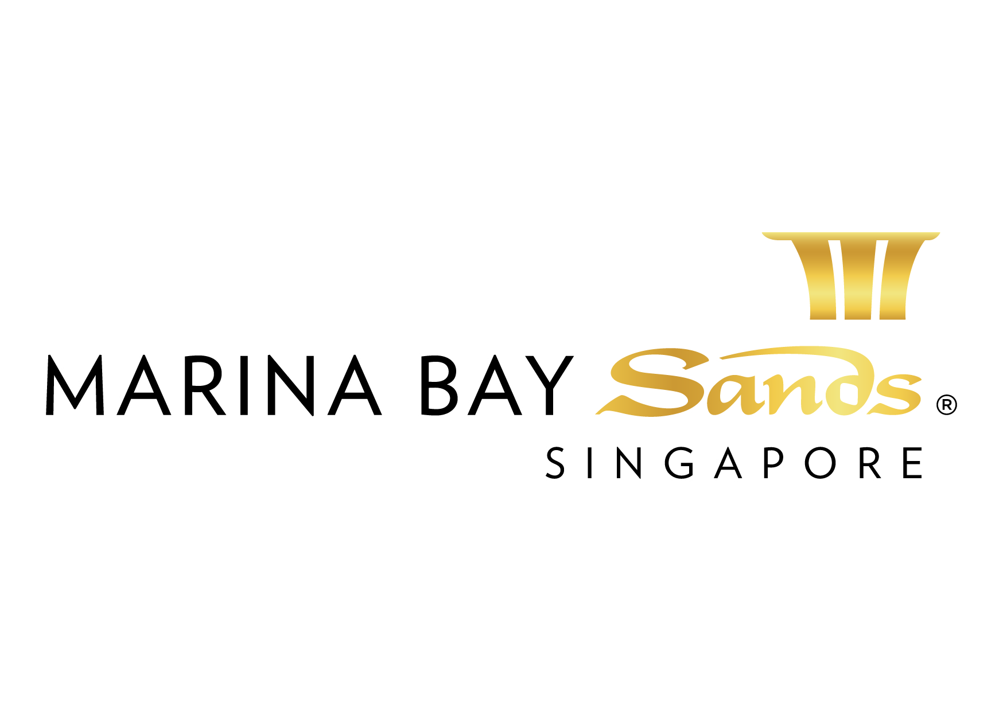 | CATERING ORDER FORM – 2024  E-mail or fax forms to:  MARINA BAY SANDS – ATTN: BANQUET OPERATIONS  10 BAYFRONT AVENUE SINGAPORE 018956  P: +65 6688-8570F: +65 6688 8842 E: boothcatering@marinabaysands.com  Please indicate total number of pages faxed to ensure complete order was received.
EVENT NAME: International Luxury Tourism Market 2024 (62822) |  |  | EVENT DATES: 2 – 4 July 2024 |  |  | BOOTH # / MTG. ROOM #
EXHIBITING CO. NAME: |  |  | HALL LOCATION: Level 1, Halls A & B
STREET ADDRESS: |  | CITY: |  |  | STATE: | ZIP:
TELEPHONE: |  | FAX: |  |  | E-MAIL:
ORDERED BY:(Print Name) |  |  |  | SIGNATURE:
IMPORTANT: SANDS EVENT SERVICES IS THE EXCLUSIVE CATERING/FOOD & BEVERAGE PROVIDER AT THE SECC. NO OTHER PROVIDER OR CATERING SERVICE WILL BE ALLOWED ON THE SHOW FLOOR AT ANY TIME.ANY EXCEPTION MUST BE APPROVED IN WRITING AND A CORKAGE FEE WILL APPLY.ALL PRICES ARE SUBJECT TO 10% SERVICE CHARGE AND PREVAILING TAXES.NO CREDITS WILL BE ISSUED ON SERVICES INSTALLED AS ORDERED EVEN THOUGH NOT USED.ALL ORDERS ARE SUBJECT TO A CANCELLATION FEE. REVIEW INVOICE PRIOR TO DEPARTURE. FOR CREDIT CONSIDERATION, ALL SERVICE CONCERNS MUST BE MADE KNOWN DURING THE SHOW.

ITEM  DESCRIPTION | QTY  REQ’D | ADVANCE RATE (21 days prior to the start of show day) | STANDARD RATE (14 days prior to the start of show day) | ONSITE RATE (On show day) | TOTAL (S$)
SANDWICHES
Cucumber, Lettuce and Tomato Finger Sandwiches (24 pcs) ** |  | $55.00 | $64.00 | $72.00
Turkey Ham and Cheese Finger Sandwiches (24 pcs) |  | $55.00 | $64.00 | $72.00
Chicken Sandwiches (24 pcs) ** |  | $55.00 | $64.00 | $72.00
Tuna Sandwiches (24 pcs) ** |  | $55.00 | $64.00 | $72.00
Egg Salad Sandwiches (24 pcs) ** |  | $55.00 | $64.00 | $72.00
PASTRIES
Assorted Cookies (30 pcs) |  | $60.00 | $68.00 | $74.00
Chocolate Brownies (30 pcs) |  | $60.00 | $68.00 | $74.00
Danish Pastries (30 pcs) |  | $60.00 | $68.00 | $74.00
Assorted Muffins (30 pcs) |  | $60.00 | $68.00 | $74.00
Mini French Pastries (30 pcs) |  | $60.00 | $68.00 | $74.00
Assorted Kueh Lapis (Local Layered Cake) (30 pcs) ** |  | $60.00 | $68.00 | $74.00
Assorted Macaroons (30 pcs) |  | $68.00 | $78.00 | $86.00
DEEP FRIED ITEMS
Chicken Spring Roll (30 pcs) ** |  | $65.00 | $74.00 | $85.00
Vegetarian Spring Roll (30 pcs) ** |  | $65.00 | $74.00 | $85.00
Vegetarian Samosa (30 pcs) ** |  | $65.00 | $74.00 | $85.00
Fried Curry Puff (vegetarian) (30 pcs) ** |  | $65.00 | $74.00 | $85.00
Fried Curry Puff (chicken) (30 pcs) ** |  | $65.00 | $74.00 | $85.00
Potato Wrapped with Prawn (30 pcs) ** |  | $65.00 | $74.00 | $85.00
Prawn Stuffing You Tiao (Prawn Stuffed Fritters) (30 pcs) ** |  | $65.00 | $74.00 | $85.00
Chicken Money Bag (30 pcs) ** |  | $65.00 | $74.00 | $85.00
 |  |  |  | SERVICE CHARGE 10% :
 |  |  |  | Prevailing GST % :
 |  |  |  | GRAND TOTAL:
**Denotes Harvest Menu

CATERING ORDER FORM – 2024
FORM 7i

E-mail or fax forms to:
MARINA BAY SANDS – ATTN: BANQUET OPERATIONS
10 BAYFRONT AVENUE SINGAPORE 018956
P: +65 6688-8570 F: +65 6688-8842 E: boothcatering@marinabaysands.com
Please indicate total number of pages faxed to ensure complete order was received.

ITEM  DESCRIPTION | QTY  REQ’D | ADVANCE RATE (21 days prior to the start of show day) | STANDARD RATE (14 days prior to the start of show day) | ONSITE RATE (On show day) | TOTAL (S$)
BAKED ITEMS
Mini Chicken Curry Pie (24 pcs) ** |  | $55.00 | $64.00 | $72.00
Mini Egg Tart (24 pcs) ** |  | $55.00 | $64.00 | $72.00
Chicken Sausage Roll (24 pcs) |  | $55.00 | $64.00 | $72.00
Chicken Pie (24 pcs) ** |  | $55.00 | $64.00 | $72.00
Mushroom Pie (24 pcs) |  | $55.00 | $64.00 | $72.00
Tuna Puff (24 pcs) ** |  | $55.00 | $64.00 | $72.00
Baked Chinese Red Bean Puff (V) (24 pcs) ** |  | $55.00 | $64.00 | $72.00
Vegetarian Curry Pie (24 pcs) ** |  | $55.00 | $64.00 | $72.00
Mini Salmon & Potato Puff (24 pcs) |  | $55.00 | $64.00 | $72.00
GIN (per bottle)
Gordon’s |  | $240.00 | $250.00 | $260.00
Bombay Sapphire |  | $280.00 | $290.00 | $300.00
VODKA (per bottle)
Skyy |  | $240.00 | $250.00 | $260.00
Grey Goose |  | $280.00 | $290.00 | $300.00
RUM (per bottle)
Mount Gay Gold Rum |  | $240.00 | $250.00 | $260.00
Bacardi Carta Blanca |  | $280.00 | $290.00 | $300.00
WHISKY (per bottle)
Johnnie Walker Red Label |  | $240.00 | $250.00 | $260.00
Jack Daniel |  | $280.00 | $290.00 | $300.00
Johnnie Walker Black Label |  | $280.00 | $290.00 | $300.00
BOURBON (per bottle)
Jim Beam White |  | $240.00 | $250.00 | $260.00
Maker’s Mark |  | $280.00 | $290.00 | $300.00
CHAMPAGNE (per bottle)
Piper Heidsieck Brut NV, France |  | $120.00 | $130.00 | $140.00
Piper Heidsieck Rosé Sauvage, France |  | $145.00 | $155.00 | $165.00
SPARKLING (per bottle)
Piccini Prosecco Vino Spumante Extra Dry NV DOC, Italy |  | $75.00 | $85.00 | $95.00
DATE & TIME DELIVERY / REMARKS : |  |  |  | TOTAL:
 |  |  |  | SERVICE CHARGE 10% :
 |  |  |  | Prevailing GST % :
 |  |  |  | GRAND TOTAL:
**Denotes Harvest Menu

CATERING ORDER FORM – 2024
FORM 7i

E-mail or fax forms to:
MARINA BAY SANDS – ATTN: BANQUET OPERATIONS
10 BAYFRONT AVENUE SINGAPORE 018956
P: +65 6688-8570 F: +65 6688-8842 E: boothcatering@marinabaysands.com
Please indicate total number of pages faxed to ensure complete order was received.

ITEM  DESCRIPTION | QTY  REQ’D | ADVANCE RATE (21 days prior to the start of show day) | STANDARD RATE (14 days prior to the start of show day) | ONSITE RATE (On show day) | TOTAL (S$)
SOFT DRINKS (per case of 24 cans)
Coke |  | $50.00 | $60.00 | $70.00
Coke Light |  | $50.00 | $60.00 | $70.00
Sprite |  | $50.00 | $60.00 | $70.00
Ginger Ale |  | $50.00 | $60.00 | $70.00
Bitter Lemon |  | $50.00 | $60.00 | $70.00
Tonic Water |  | $50.00 | $60.00 | $70.00
Soda Water |  | $50.00 | $60.00 | $70.00
Red Bull |  | $140.00 | $150.00 | $160.00
HOUSE WINE (per bottle)
House Wine (Red) |  | $67.00 | $70.00 | $75.00
House Wine (White) |  | $67.00 | $70.00 | $75.00
WATER (per case of 24 bottles)
House Bottled Water (500ml) |  | $48.00 | $50.00 | $52.00
Perrier (330ml) |  | $90.00 | $92.00 | $94.00
Voss Water (500ml) |  | $86.00 | $88.00 | $90.00
San Pellegrino (500ml) |  | $90.00 | $92.00 | $94.00
CHILLED OR CANNED JUICE
Orange Juice (2 Litres) |  | $40.00 | $42.00 | $44.00
Orange Juice (per case of 24 bottles) |  | $72.00 | $74.00 | $76.00
Fruit Punch (2 Litres) |  | $40.00 | $42.00 | $44.00
Pineapple Juice (2 Litres) |  | $40.00 | $42.00 | $44.00
Apple Juice (2 Litres) |  | $40.00 | $42.00 | $44.00
Apple Juice (per case of 24 bottles) |  | $72.00 | $74.00 | $76.00
BEER
Tiger (30 Liters Keg) serves approx. 90 glasses  (exclude powerpoint) |  | $820.00 | $840.00 | $860.00
Tiger (per case of 24 cans) |  | $185.00 | $195.00 | $205.00
Heineken (per case of 24 cans) |  | $205.00 | $215.00 | $225.00
DATE & TIME DELIVERY / REMARKS : |  |  |  | TOTAL:
 |  |  |  | SERVICE CHARGE 10% :
 |  |  |  | Prevailing GST % :
 |  |  |  | GRAND TOTAL:
CATERING ORDER FORM – 2024
FORM 7i

E-mail or fax forms to:
MARINA BAY SANDS – ATTN: BANQUET OPERATIONS
10 BAYFRONT AVENUE SINGAPORE 018956
P: +65 6688-8570 F: +65 6688-8842 E: boothcatering@marinabaysands.com
Please indicate total number of pages faxed to ensure complete order was received.

ITEM  DESCRIPTION | QTY  REQ’D | ADVANCE RATE (21 days prior to the start of show day) | STANDARD RATE (14 days prior to the start of show day) | ONSITE RATE (On show day) | TOTAL (S$)
SNACK & FINGER FOOD
Assorted Lay Chips (28gm) |  | $2.40 | $2.60 | $2.90
Packaged Mixed Nuts (40gm) |  | $1.40 | $1.80 | $2.20
Packaged Mixed Nuts (1Kg) |  | $19.00 | $22.00 | $24.00
Assorted Fun Size Chocolate Bars (10pcs) |  | $14.00 | $19.00 | $24.00
SERVICE PERSONNEL (MINIMUM 4 HOURS BLOCK)
Food Server (min block 4 hours) |  | $200.00 | $210.00 | $220.00
Bartender (min block 4 hours) |  | $200.00 | $210.00 | $220.00
Mixologist (min block 4 hours) |  | $600.00 | $630.00 | $660.00
Chef (min block 4 hours) |  | $200.00 | $210.00 | $220.00
Subsequent hour (per hour charge) |  | $50.00 | $60.00 | $70.00
Over 8 hours (per hour charge) |  | $75.00 | $85.00 | $95.00
COFFEE MACHINE
Coffee Machine Package includes (per event rental):  - coffee machine  - 50 Coffee Capsules  - 50 sachets sugar  - 50 pcs disposable cups (8oz)  - 50 pcs stirrer  - 50 pcs creamer  The machine excludes power point and water. |  | $225.00 | $245.00 | $265.00
COFFEE / TEA
Coffee Pot (1 gallon, serves approx. 18 cups) |  | $50.00 | $55.00 | $60.00
Tea Pot (1 gallon, serves approx. 18 cups) |  | $50.00 | $55.00 | $60.00
GLASSES
Highball (36 pcs) |  | $38.00 | $39.00 | $40.00
Flute (36 pcs) |  | $38.00 | $39.00 | $40.00
Wine (25 pcs) |  | $38.00 | $39.00 | $40.00
Multi-Purpose Glass (25 pcs) |  | $38.00 | $39.00 | $40.00
Rock Glasses (25 pcs) |  | $38.00 | $39.00 | $40.00
DATE & TIME DELIVERY / REMARKS : |  |  |  | TOTAL:
 |  |  |  | SERVICE CHARGE 10% :
 |  |  |  | Prevailing GST % :
 |  |  |  | GRAND TOTAL:

CATERING ORDER FORM – 2024
FORM 7i

E-mail or fax forms to:
MARINA BAY SANDS – ATTN: BANQUET OPERATIONS
10 BAYFRONT AVENUE SINGAPORE 018956
P: +65 6688-8570 F: +65 6688-8842 E: boothcatering@marinabaysands.com
Please indicate total number of pages faxed to ensure complete order was received.

ITEM  DESCRIPTION | QTY  REQ’D | ADVANCE RATE (21 days prior to the start of show day) | STANDARD RATE (14 days prior to the start of show day) | ONSITE RATE (On show day) | TOTAL (S$)
CROCKERY & CUTLERY
Side Plate (per dozen) |  | $15.00 | $16.00 | $17.00
Entrée Plate (per dozen) |  | $15.00 | $16.00 | $17.00
Knife (per dozen) |  | $15.00 | $16.00 | $17.00
Fork (per dozen) |  | $15.00 | $16.00 | $17.00
Dessert Spoon (per dozen) |  | $15.00 | $16.00 | $17.00
China Coffee Service (cup, saucer, teaspoon) per dozen |  | $15.00 | $16.00 | $17.00
Disposable cups 8oz (25pcs) |  | $7.00 | $8.00 | $10.00
Disposable stirrers (50pcs) |  | $5.00 | $5.00 | $6.00
Disposable Fork / Spoon / Knife (12pcs) *(3 in 1) |  | $7.00 | $8.00 | $10.00
Disposable Plates (12pcs) |  | $10.00 | $11.00 | $12.00
Disposable Solo Clear Cups (100pcs) |  | $20.00 | $21.00 | $22.00
Disposable Wine Glass (10pcs) |  | $8.00 | $9.00 | $10.00
Disposable Flutes (6pcs) |  | $8.00 | $9.00 | $10.00
OTHERS
Coffee Capsules (a box of 50 capsules) |  | $175.00 | $185.00 | $195.00
Lipton Tea Bags (100 sachets) |  | $36.00 | $38.00 | $41.00
White Sugar (50 sachets) |  | $7.00 | $8.00 | $10.00
Brown Sugar (50 sachets) |  | $7.00 | $8.00 | $10.00
Equal (50 sachets) |  | $14.00 | $16.00 | $17.00
Kaffee Creamer (50 portions) |  | $14.00 | $16.00 | $17.00
Fresh Milk (UHT) 1 Litre |  | $6.00 | $7.00 | $8.00
Ice Cube (3.0kg per pack) |  | $10.00 | $11.00 | $12.00
Linen Napkins (10pcs) |  | $10.00 | $11.00 | $12.00
Disposable Napkins (200pcs) |  | $10.00 | $11.00 | $12.00
Table cloth |  | $15.00 | $16.00 | $17.00
Oblong Table |  | $30.00 | $33.00 | $36.00
Water Dispenser Package Includes (per event rental) :  - 100 pcs disposable cups (8oz)  - 5 Gallon Water  The machine excludes power point. |  | $125.00 | $125.00 | $130.00
Distilled Drinking Water (5 Gallon) |  | $20.00 | $20.00 | $20.00
DATE & TIME DELIVERY / REMARKS : |  |  |  | TOTAL:
 |  |  |  | SERVICE CHARGE 10% :
 |  |  |  | Prevailing GST % :
 |  |  |  | GRAND TOTAL:

